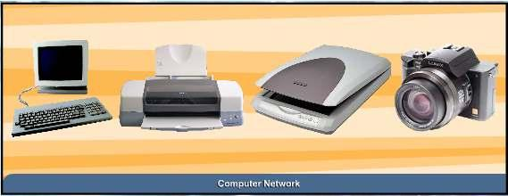
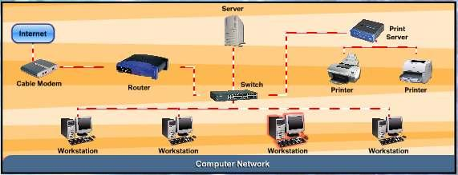
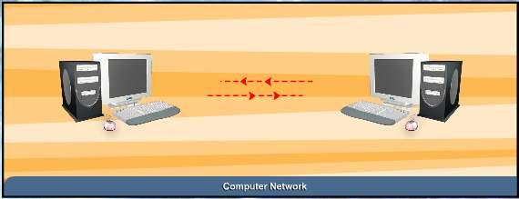
M. Amin, SMK Raja Shahriman
COMPUTER NETWORKS
AND COMMUNICATIONS

LESSON 67
INTRODUCTION TO COMPUTER NETWORKS AND
COMMUNICATIONS

COMPUTER NETWORK

A computer network is a system of interconnected computers and peripheral
devices. For example, it may connect computers, printers, scanners and
cameras.

151
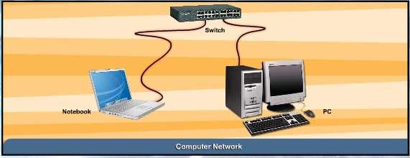
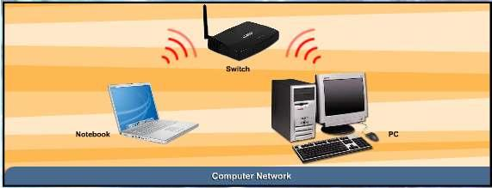
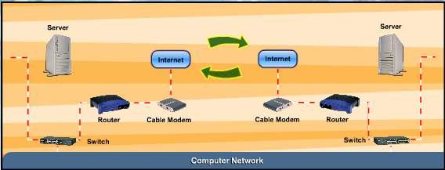
M. Amin, SMK Raja Shahriman
Using hardware and software, these interconnected computing devices can
communicate with each other through defined rules of data communications.
In a network, computers can exchange and share information and resources.

A computer network may operate on wired connections or wireless
connections.

When two or more networks are linked or connected and are able to
communicate with one another using suitable hardware and software, it is
called an internetwork.

152

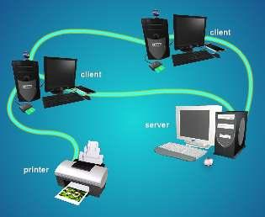
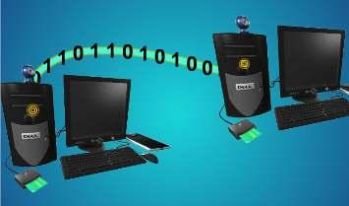
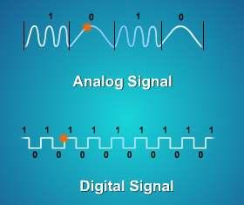
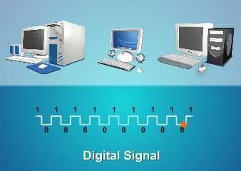
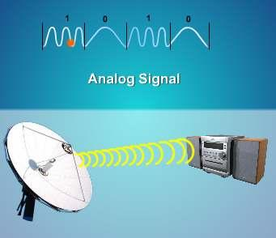
COMMUNICATIONS
Communications is about the
transfer of information from a
sender, across a distance, to a
receiver.

Using electricity, radio waves or
light, information and data in the
form of codes are transmitted
through a physical medium such as
wire, cable, or even the atmosphere.

The information that is transmitted
(sent) can be text, voice, sound,
video, graphics and images, or a
combination of all these, which we
call multimedia.
M. Amin, SMK Raja Shahriman

We transmit information or data by
using two types of signals, namely
analog and digital.

Computers communicate with digital signals. The older forms of
communications technology, such as telephones and radios, use analog
signals.

153

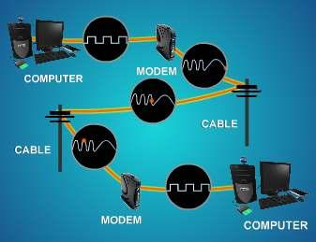
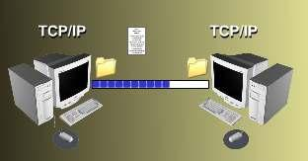
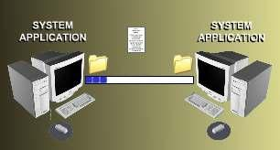
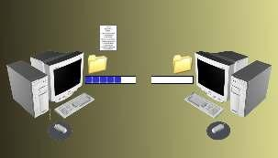
Therefore, in order to make
communications possible from
computers, across telephones
and radios and back to computers
and other digital devices again,
there must be a signal translator,
which we call – a modem.

The modem, which is short for
modulator or demodulator,
converts digital signals into
analog and back again into
digital signals for information to
move across the telephone line.

CONNECTIONS FOR NETWORKING
Communications among computing
devices in a network can only
happen through defined rules of
communications and connections.

In general, for communications in a
network to be possible, there must
be:
a physical medium – to allow
data to travel across it from device to device
a set of rules called protocols
to ensure that interconnected
computing devices have the
same standards for exchange
of information to occur
smoothly.
a system application for
managing network information
flow to ensure that data
M. Amin, SMK Raja Shahriman

transmission sent from one device is received by the intended
receiver.

If any of these levels of connectivity
is missing, communications for
networking will not be possible.
For example, if the physical medium
is cut off, there will be no
communications.

154

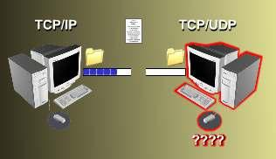
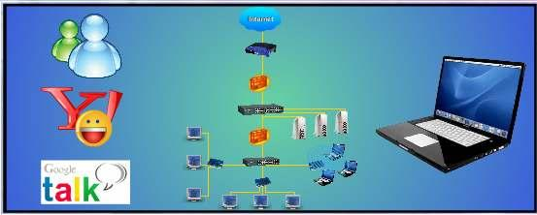
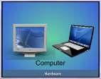
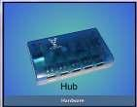
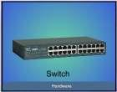
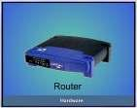
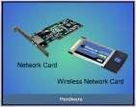
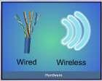
If protocol between interconnected
devices are not the same, data
transmission will not be ‘understood’
between devices.

If there is no network management
application available, there will be
no means of ensuring that
information from one device will be
sent to the correct receiving device.

Protocol
M. Amin, SMK Raja Shahriman

Often simply referred to as a protocol, a communications protocol is a set of
rules or standards designed so that computers can exchange information
with a minimal errors.

LESSON 68
COMPONENTS OF COMMUNICATIONS

INTRODUCTION

In order for a network to properly operate, two categories of network
communications components are needed; ‘Hardware’ and ‘Software’.

Computers, hub, switch, router,
network interface cards and both
wired and wireless communications
media fall under the ‘Hardware’
category.

155

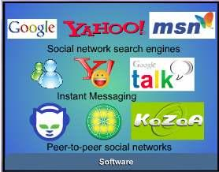
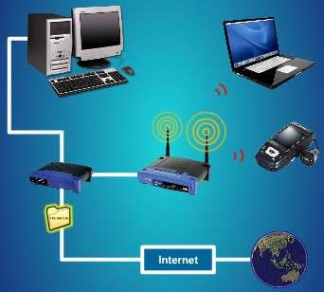

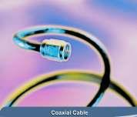
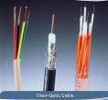
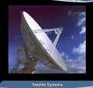
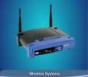
M. Amin, SMK Raja Shahriman

Operating systems and applications fall
under the ‘Software’ category.

NETWORK COMMUNICATION CHANNELS

Signals which carry information
in a communications system
travel through a physical
medium.

This physical medium is called
a communications channel, or at
other times a communications
link, a communications line, or
a communications medium.

Some common types of network
communications channels are
the:
twisted-pair wire
coaxial cable
fiber-optic cable
satelite systems
wireless systems (namely using radiowaves, microwaves and
infrared)

Communications channels provide the most basic level
of connectivity medium for a network.

156
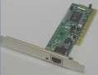
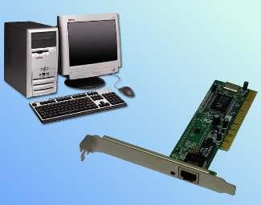
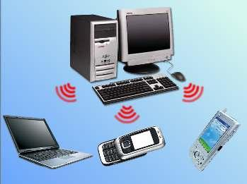
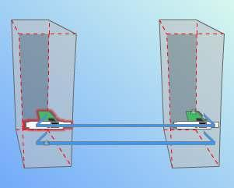
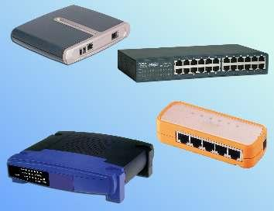
M. Amin, SMK Raja Shahriman
NETWORK INTERFACE CARDS AND NETWORKING
DEVICES

The Network Interface Card or NIC is one of the most
important communications devices for a PC.

The NIC provides connection
between the computer and the
network’s communications media.

This connection is necessary because
the NIC functions as a data conversion
device to move data from the PC’s
system to the network medium and
vice versa.

The Network Interface Card also
supplies the basic addressing system
used to get data from PC to PC across a
network.

The other hardware component that is
required for communications to work
on a network is the networking device,
such as the hub, switch, router and
even the modem.

The function of these devices is
generally to control the flow of data on
a network.

157

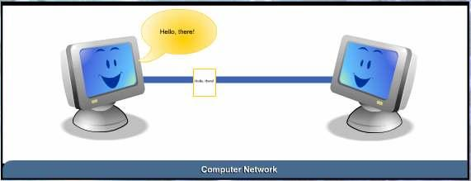
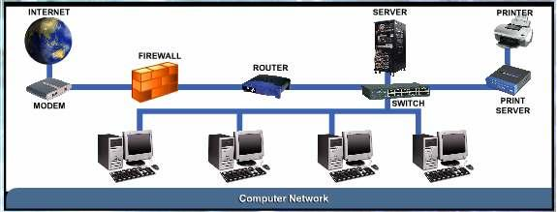

NETWORK SOFTWARE

How do computers communicate on a network?
M. Amin, SMK Raja Shahriman

Once we have got the necessary hardware set up for a network, we will
need to have suitable software on the network computers that would be
able to provide some basic functions, such as connecting to
other computers on the network, sharing resources and
files and providing for network security for users who are
online.

In general, a network software must be able to handle networking protocols
and connections within the network and with other networks. Most
importantly, it should also provide file systems functions to organise disk
space on the network computers for sharing purposes.

Since most computer networks are connected to the Internet, a network
software must have some form of management and security services to
protect the network as well as computers on the network, from
unauthorised access.

158







LESSON 69
M. Amin, SMK Raja Shahriman

IMPORTANCE OF NETWORKS AND COMMUNICATIONS

Networking and communications technology is fast changing the way people
view society and how we plan our daily social activities.

Through networking technology alone, many today are
finding friends online, visiting a library in another
country. Some people are able to go to the banks
after they are closed, as well as getting the latest
development in news from within and outside the
country.

Mobile communications today is also based on the
networking technology. Surfing the internet is not only
limited to the desktop computer users but also those
who have mobile phones with wireless technology. At
present there are more than 7 million such users
across the world.

The internet has helped science and medical research
progress further as doctors and researchers from
anywhere in the world can contribute and cooperate in
any problem brought to their attention. Technological
solutions can be discovered quickly as individuals
come forward to offer their help through the internet.

Homemakers, students, teachers, business people,
and almost anyone with access to networked
computer go online and continue their path of lifelong
education anywhere, anytime.

Organisations and individuals can make connections
and establish communications within seconds with
people nearby or overseas. Online communities can be
formed and important issues and opinions to difficult
problems can be discussed without a threatening
environment.

All these are now possible because of networks and communications
technology.

159


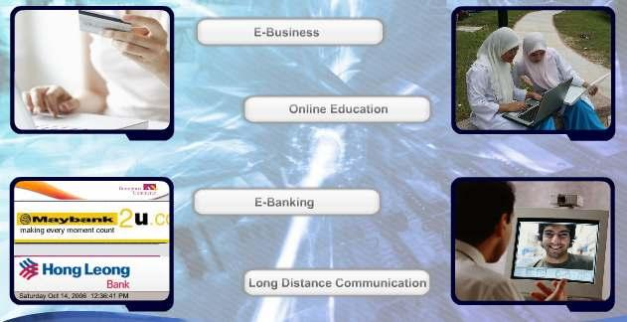


IMPORTANCE OF NETWORKS AND
COMMUNICATIONS
M. Amin, SMK Raja Shahriman

Information is now made easy with the availability of network
communications.

In a clinic for example, network communications
plays an important part in keeping patients’
database for easy retrieval. Unlike in conventional
practice, doctors and nurses have to look for a
patient’s personal file from hundreds or maybe
thousands of records. With network
communication, the clinic saves time and
manpower allocation can be effectively planned.

E-Business
E-business or electronic business refers to
conducting business transactions on the
internet, not only limited to buying and selling
but also servicing customers and collaborating
with business partners.

E-business supports many types of business
transactions, including online shopping, selling
and renting. Users can browse the website and
choose from the list of items or services to
buy. Payment is usually via credit card.

160



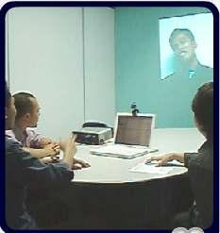

Online Education
With a network connections, online
education is made possible.
Students at any location around the
world can participate in an online
classroom, download tutorial
questions and submit their
assignments.

E-Banking
E-banking or electronic banking is the most
popular banking facility nowadays. It handles
all types of banking transactions like account
management, fund transfer and payments
primarily over the internet.

User can pay bills, check the account balance
and transfer money to other parties, using e-
banking facilities twenty four hours a day and
seven days a week.

With e-banking, most of the transactions can
be done at home or from the office, thus users
save time on traveling and queuing at the bank
counters.

Long Distance Communication
Long distance communication is made easy via
network availability. Communication is possible
via voice, text or video. The cost of having this
type of communication is cheaper than making
a normal phone call and definitely faster and
more effective than corresponding via letters of
fax.

In business, important decisions can effectively
made through video conference meeting.

161
M. Amin, SMK Raja Shahriman

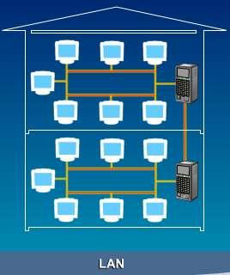
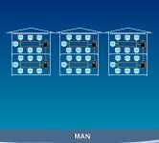

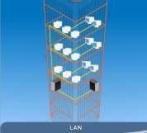
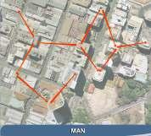
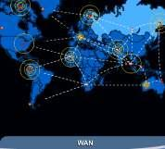
LESSON 70
TYPES OF NETWORKS

TYPES OF NETWORKS

Three types of networks:
Local Area Network or LAN
Metropolitan Area Network or MAN
Wide Area Network or WAN

Here:
M. Amin, SMK Raja Shahriman

LAN - the email system within the school lab in SMK KL
MAN - the email system within KL city
WAN - the email system between KL and London

A LAN covers a small region of space, typically a single building.

A MAN is a collection of LANs with the same geographical area, for instance
a city.

A WAN can be a collection of LANs or MANs or the mix of two with a very
large geographical area, for instance a country or even beyond the border.

LESSON 71

162

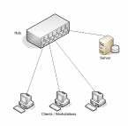

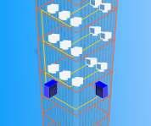
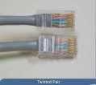


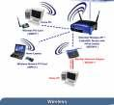
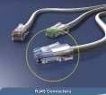
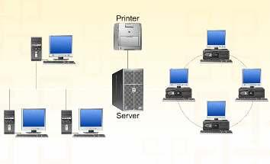
LOCAL AREA NETWORK (LAN)

Local Area Network (LAN) is the smallest network
compared to the other two networks.
M. Amin, SMK Raja Shahriman

The simplest form of LAN is to connect two computers
together.

LAN is operated within a limited physical area, such as
at home, school, a single building or
several buildings.

A network which consists of less
than 500 interconnected devices
across several buildings, is still
recognised as a LAN.

Inexpensive hardware used in LAN previously include
twisted pair, coaxial cables and the higher end is fiber
optic or wireless.

However, coaxial cables are now being replaced by a
higher speed cabling system
such as CAT5 using RJ45 connectors.

LAN is a very high speed network (from previously
10Mbps) to 100Mbps, which is faster than MAN and WAN.

Local Area
Network is a group of computers
and network devices connected
together, usually within the same
building.

LESSON 72
163

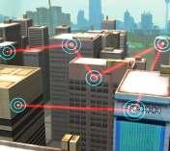
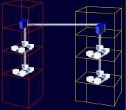
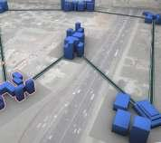
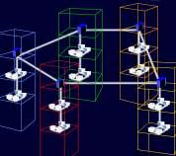
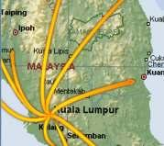
METROPOLITAN AREA NETWORK (MAN)

First, you have to understand the word
metropolitan. Metropolitan describes
important cities such as Kuala Lumpur, Manila,
Singapore, Tokyo, London and New York.

MAN is a network of computers located at
different sites within a large physical area, such
as a city. Companies that have several branches
within the Kuala Lumpur city such as banks,
might find a MAN useful to them.

In this case, setting up a MAN across long
distances can be best connected using fiber
optics. Sometimes, a MAN can be a collection of
several LANs within the same city.

MAN often acts as a high speed network
(although not as fast as a LAN) to allow
sharing of regional resources.

MAN can be
defined as a group
of computers and
network devices
connected
together within a
large physical
area.

LESSON 73
WIDE AREA NETWORK (WAN)

Wide Area Network (WAN) is the largest network
of all network types. The Internet is the largest
WAN in the world. WAN generally covers large
distances such as states, countries or
continents.

164
M. Amin, SMK Raja Shahriman

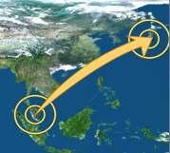
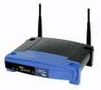
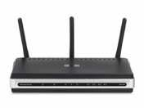

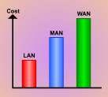


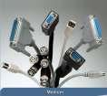
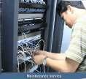
An example in the society using WAN is the
banking organisation. Local banks have always
maintained their business online by connecting
all computers of their branches in the countries.
International banks also use WAN to connect
their computers all over the world.

Actually, WAN is a group of MANs or LANs or the
mixture of both networks.

A device called a router is
needed to connect the MANs
and LANs all over a large
physical area. A router is a
special networking device
that connects two or more
different networks and keeps
data flowing between them.
M. Amin, SMK Raja Shahriman

A router makes all the different networks communicate,
such as connecting LAN to LAN, LAN to WAN or WAN to
WAN.

The transmission media in WAN uses the fibre optic
cable.WAN is still considered a fast network with speeds
20 – 2000 Kbps, but slower than LAN and MAN.

LESSON 74
DIFFERENCES BETWEEN TYPES OF NETWORK

SETTING UP COST

Setting up a MAN network is more expensive than a LAN
but less than a WAN. Managers have to consider the cost
of buying the necessary hardware, software, medium and
maintenance service for the desired network.

165

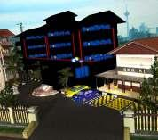
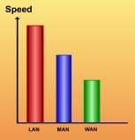
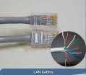
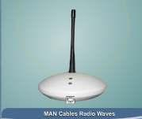
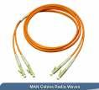


NETWORK SIZE
The network size of a MAN falls between LAN
and WAN. As you know, a LAN usually covers
only a limited area such as a school lab; a MAN
will cover a greater area such as a city while a
WAN will cover the largest geographical area
such as the size of Malaysia.

SPEED
LAN offers the best speed in transmitting information
followed by MAN and WAN. In addition, LANs are
capable of transmitting data at very fast rates, much
faster than data which is transmitted over a
telephone line although the distances are limited.

LAN is also frequently used to provide a shared
connection to other networks using a link to a WAN.

A MAN often acts as a high speed network to allow
M. Amin, SMK Raja Shahriman

sharing of regional resources (similar to a large LAN). For larger network
coverage, MAN is a better choice for a higher speed connection compared to
a WAN.

TRANSMISSION MEDIA
A LAN uses the cheapest transmission media
compared to MAN and WAN. Generally LAN only uses
communication media such as twisted-pair cables.

A MAN might have more than one transmission media since it involves a
combination of two or more LANs and the media used depends on the
network coverage. Here, a MAN might use the twisted-pair and fibre-optics
cables.

166

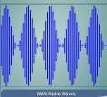
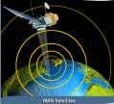
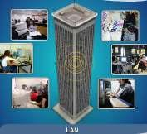
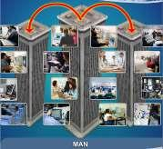
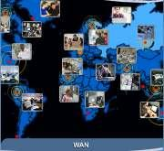
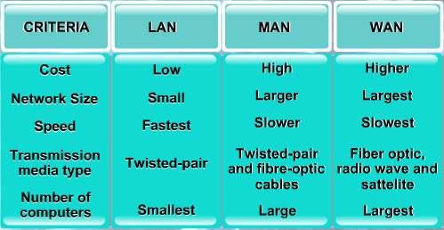
A WAN might use costly
transmission medias such as
fibre-optics, radio waves and
satellites, depending on their
coverage.

CONNECTION LIMIT
M. Amin, SMK Raja Shahriman

The number of computers that can be attached to a single LAN is limited.

A MAN can have a large number of computers compared to a LAN but less
than a WAN.

A WAN can have up to billions of computers attached to it.

COMPARISON OF LAN, MAN AND WAN

167

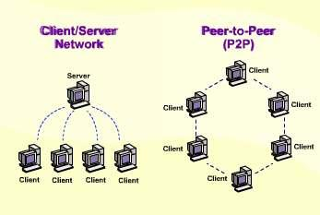
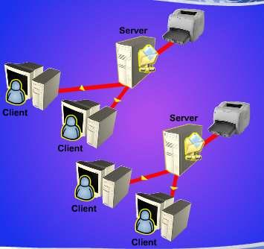
LESSON 75
NETWORK ARCHITECTURE
M. Amin, SMK Raja Shahriman

TYPES OF NETWORK ARCHITECTURE
Network architecture is the
overall design of a computer
network that describes how a
computer network is configured
and what strategies are being
used.

Network architecture mainly
focuses on the functions of the
networks. Network architecture
is also known as network model
or network design.

There are two main network architectures:
client/server network
peer-to-peer network

CLIENT/SERVER NETWORK
A client/server network is a network
in which the shared files and
applications are stored in the server
but network users (clients) can still
store files on their individual PCs.

A server is a computer that shares
information and resources with other
computers on a network. A client is
a computer which requests services
or files from a server computer.

168

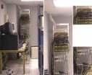
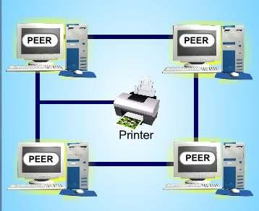
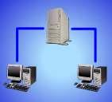
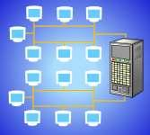
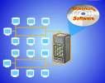

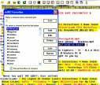
PEER-TO-PEER NETWORK
Peer-to-peer or P2P network is a
network with all the nodes acting as
both servers and clients. A PC can
access files located on another PC and
can also provide files to other PCs.

All computers in the peer-to-peer
network has equal responsibilities and
capabilities to use the resources
available on the network.

With peer-to-peer network, no server
is needed; each computer in the
network is called a peer.

LESSON 76
CLIENT / SERVER

CLIENT / SERVER NETWORK
On a client/server network, shared files and
M. Amin, SMK Raja Shahriman

applications are stored in the server but network users
can still store files on their individual PCs.

A smaller client/server network uses twisted-pair or
coaxial cables for networking but a larger and
powerful network will use fibre optics. A client/server
network is suitable for connecting 10 or more
computers.

To set up a client/server network, you need to install
a server program for the server and a client program
for the clients. A network administrator needs to
configure access rights on the server side to allow
access for the clients to use the resources.

An email program is an example
of a client program, as it sends
email requests to a mail server.

IRC (Internet Relay Chat),
Internet browser and email
program are examples of
software applications for a
client/server network.

169

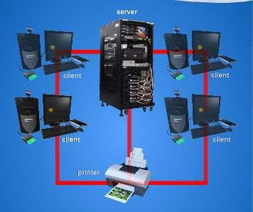
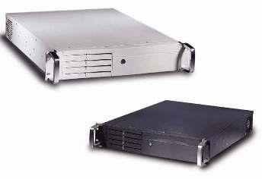
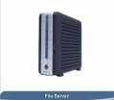
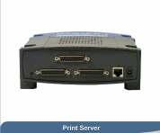
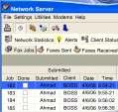
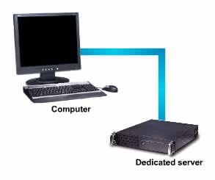
SERVER
A server is sometimes called a
host computer. A server is a
computer that provides
services to other computers
called clients. A server controls
access to the hardware,
software and other resources
on the network.

It provides a centralised
storage area for programs,
data and information.

DEDICATED SERVER
M. Amin, SMK Raja Shahriman

Dedicated servers perform specific tasks and usually execute only one job.

For example, a file server stores and
manages files, a print server manages
printers and print jobs. A database server
stores and provides access to a database.
A network server manages network traffic.

A dedicated server helps save
time and storage space in one
computer. It will not put the
whole network at risk if it fails.

CLIENT
170

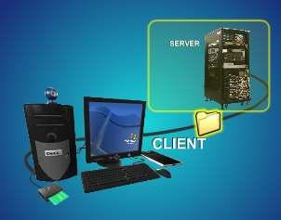
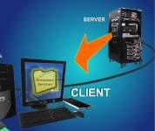
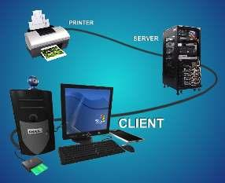
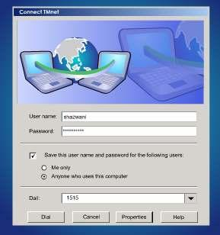
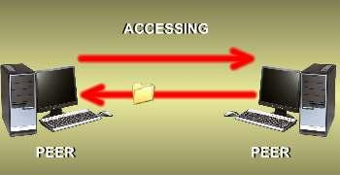
The client computers are computers on the
network that rely on the server for its
resources and services.

Client computers send requests to a server
for resources or services to perform their
job. For example, a client computer can
send a request asking permission to use the
printer attached to the server, to print a
document.

Usually a client computer has to log onto
the network using a user name and
password to use the server’s resources and
services.

For example, you have to be a TMnet or
Jaring member to use the internet service.
You need to logon to TMnet or Jaring’s
server by sending your username and
password.

After your
successful
login process,
then you can
access the
internet
through TMnet
or Jaring’s
server.

LESSON 77
PEER-TO-PEER

PEER-TO-PEER FUNCTIONS
Peer-to-peer (P2P) network is a
network with all the nodes
acting as both servers and
clients. A PC can access files
located on another PC and can
also provide files to other PCs.

171
M. Amin, SMK Raja Shahriman
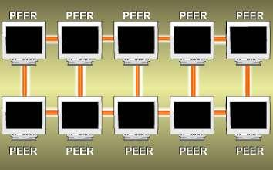
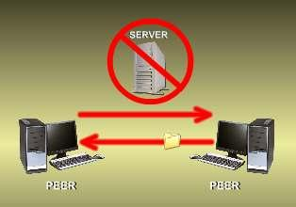
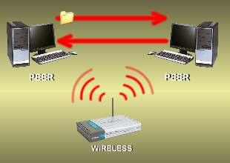



A P2P network usually uses
twisted-pair or coaxial cable
because these cables are
cheaper and easier to work
with.

P2P network is the best choice
to set up a network with less
than 10 computers.

P2P network is easier to manage as
long as there are network cards
installed on the PCs and connection
can be done with a network cable.
To share the resources, each PC
must have the necessary program.

There is no central server or central
router managing a P2P network.

Wireless networking can be an
example of a P2P network as
you only need a wireless card,
connect it to an existing wireless
network and resources can be
shared

Limewire, Bearshare and Kazaa are
all examples of software applications
for peer-to-peer (P2P) file sharing.

172
M. Amin, SMK Raja Shahriman
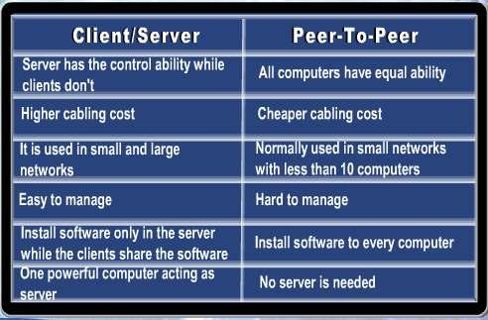

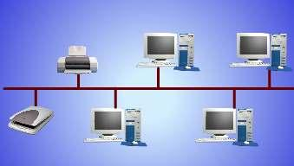
M. Amin, SMK Raja Shahriman
THE DIFFERENCES BETWEEN CLIENT/SERVER AND
PEER-TO-PEER

LESSON 78
NETWORK TOPOLOGY

Now, imagine replacing the dinner table as your
network, and the chairs are your computers. How
would you like your network to be? How would
you arrange the computers?

In networking terms, the structure you are
planning to connect the computers to, is called
network topology.

Network topology is also
referred to as the configuration
of a network.

It usually refers to the physical
arrangement of the computers
and other networking devices
that are linked together.

173

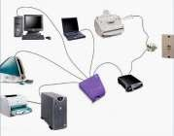
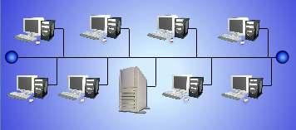
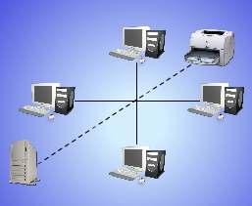
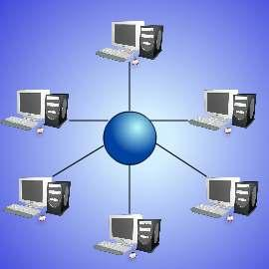
It defines how nodes are connected to one
another in a communication network. A network
topology must show the nodes and the links
between them. The nodes must be an active
device connected to the network, such as a
computer, printer, hub or a router.
M. Amin, SMK Raja Shahriman

To see a network topology clearly, always apply it on a Local Area Network
(LAN). According to the needs, there are three main types of network
topology. They are bus topology, star topology and ring topology.

Bus Topology

Star Topology

Ring Topology

174

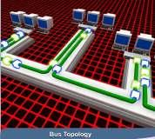
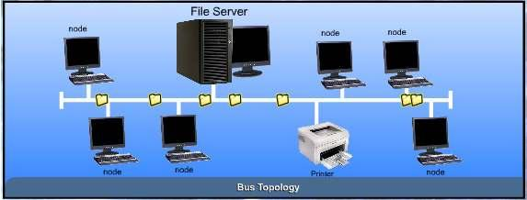
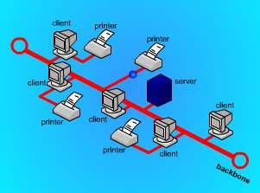
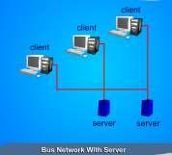
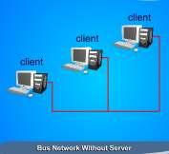
LESSON 79
BUS TOPOLOGY

In communications technology, you think of a
bus as a common “highway” on which data is
transmitted.

A bus refers to the main physical pathway or
central cable where all other devices are
connected to it. Like a major motor highway,
all traffic flow will be affected if this main
“road” is broken.
M. Amin, SMK Raja Shahriman

A bus topology consists of a single central cable to which all computers and
other devices connect. A bus topology is also known as a bus network.

DESCRIPTION OF BUS TOPOLOGY
Bus networks are very common in Local
Area Networks (LAN). A bus network
must have a common backbone (the
central cable) to connect all devices.

All nodes share the backbone to
communicate with each other on the
network. Sometimes, a bus network
has more than one server. Sometimes,
a server is not needed on the network.

175

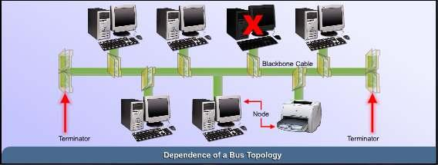
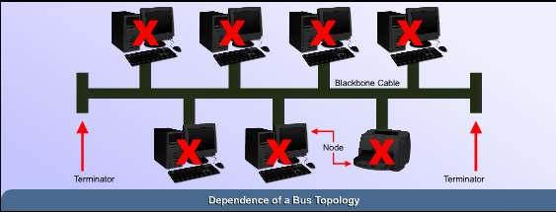
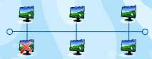
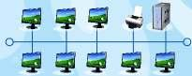
DEPENDENCE OF A BUS TOPOLOGY
M. Amin, SMK Raja Shahriman

If one of the nodes fails, the bus network would still function as long as the
backbone is working. If the backbone fails, the network will fail to function.

ADVANTAGES OF BUS TOPOLOGY

Easy implementation. New devices can be added to the backbone or to
the existing nodes.
Failure of a node doesn't affect the entire LAN.
No disruptions to the network when connecting or removing devices.
Network can easily be extended, by adding new devices to the
backbone or existing nodes.

176

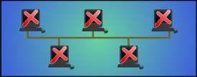
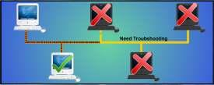
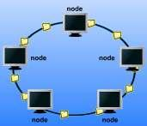
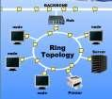
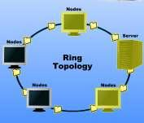

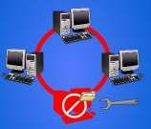
M. Amin, SMK Raja Shahriman
DISADVANTAGES OF BUS TOPOLOGY

If the backbone fails, the entire bus network will be affected.
Network speed decreases when the number of nodes increases.
Troubleshooting is difficult when one of the nodes fails.

LESSON 80
RING TOPOLOGY

A ring topology consists of all computers and
other devices that are connected in a loop.
Ring topology is also known as a ring network.

A ring network can be found in Local Area
Networks. In a ring network each node
directly connect to two neighbouring nodes.
A server may exist in a ring network, but it will
not connect to all the nodes in the network.

The server, like other nodes,
will only communicate to its two
neighbouring nodes.

DEPENDENCE OF A RING TOPOLOGY
If one of the nodes fails, the network will fail to
function.

ADVANTAGES OF A RING TOPOLOGY

Troubleshooting is easy when one of the nodes fails.
Repair or remove the failing nodes and the network
will continue to function.

177
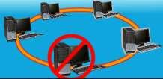
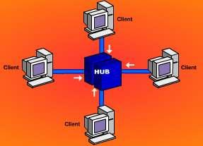
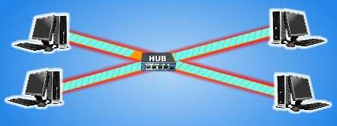
M. Amin, SMK Raja Shahriman

DISADVANTAGES OF A RING TOPOLOGY

Implementation is difficult. Network administrator has to terminate the
entire network to install a new node between existing nodes.
A failing node will affect the entire LAN.
Connecting or removing devices is difficult because network
administrator needs to terminate the network in order to do it.
Network speed decreases when the number of nodes increases.

LESSON 81
STAR TOPOLOGY

In the early days of computer
networking, all computers were
connected to a centralised mainframe
computer.

All resources and management of
information were centred in this main
computer.

The idea of a centralised mainframe
computer is where the basic concept of
a star topology comes from.

A star topology consists of a central host which acts as the centre, and all
nodes connect to the host. A star topology is also known as star network.

178

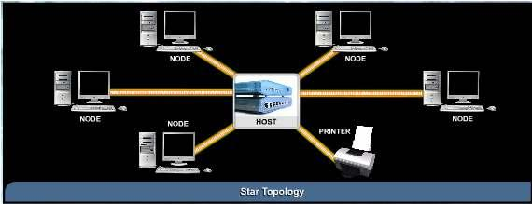
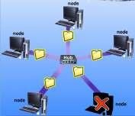
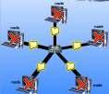
DESCRIPTION OF STAR TOPOLOGY
M. Amin, SMK Raja Shahriman

A star network is found in a Local Area Network setting.
A star network must have a host which acts as the centre.
The host can be a server, hub or router.
In a star network, every node will not connect to the neighbouring
nodes.
Every node must connect to the host in order to communicate.
The host will control the flow of communication in the network.

DEPENDENCE OF A STAR TOPOLOGY

If one of the nodes fails, the star network can still
function as long as the host is working.

If the host fails, the network will fail to function.

179

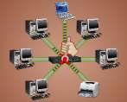
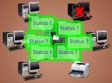
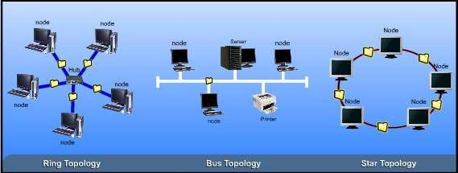
M. Amin, SMK Raja Shahriman

ADVANTAGES AND DISADVANTAGES OF STAR
TOPOLOGY

Advantages

It is easy to implement. You only add nodes to
the host.
The failure of a node does not affect the entire
LAN.
There are no disruptions to the network when
connecting or removing devices.
The network can be extended by adding new
devices to the host or nodes.
Troubleshooting is easy when the host fails. Simply repair or replace
the host and the network will continue to function.

Disadvantages

If the host fails, the entire LAN will be
affected.
Network speed decreases when the number
of nodes increases.
Troubleshooting is difficult when one of the
nodes fails.
A host must be installed to control the
network.

LESSON 82
DIFFERENCES OF NETWORK TOPOLOGIES

UNDERSTANDING DIFFERENT TOPOLOGIES

Understanding differences in network topologies helps us to see what each
topology is able to do.

180

Each topology has an influence on:
the type of equipment we will use
M. Amin, SMK Raja Shahriman

the potential of the network in accommodating more computers
the way we manage our network
the capabilities of the hardware to manage the flow of information

THE STRUCTURE NETWORK TOPOLOGY
The following table compares the structures of the three main types of the
network topologies:

Structure

Bus
Topology
there is a single

Ring
Topology
all computers and

Star
Topology
there is a central

central cable
other devices are host and all

(backbone) and all
computers and other
devices connect to it
Host existence depends on network
needs
connected in a
circle

depends on
network needs
nodes
connect to it

yes

Connection
between nodes
It has no connection
between the nodes.
yes
no

Host failure
Node failure
network can still run network will fail network will fail
network can still run network will fail network can still
run

Ease of
difficult. Need to
depends on
depends on the

troubleshooting search for the
problematic node one
by one
backbone. If
there is a
backbone,
troubleshooting is
difficult.

If there is no
backbone, the
focus is on the
two nodes not
communicating
host. It is easier
to repair the
problematic host.

However, if the
nodes fail, then
each node has to
be searched

Ease of adding
or removing
nodes
Number of
nodes when
extending
network

easy

many

difficult

limited

181

average

limited

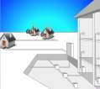



LESSON 83
M. Amin, SMK Raja Shahriman

INTRODUCTION TO NETWORK STANDARDS

Network architectures are defined by exact and
detailed specifications regarding the physical layout,
cabling and methods used to access and maintain
communications in and between network media.

The Institute of Electrical and
Electronic Engineers (IEEE), is one
international organisation responsible for developing and
providing networking technology specifications for
worldwide usage.

We call these networking technology specifications as
network standards.

COMMON NETWORK STANDARDS
Network communications use a variety of standards
to ensure that data travels correctly to its
destination.

Network standards define guidelines that specify the
way computers access the medium
to which they are attached.

The guidelines also describe the type of medium used, the speeds used on
different types of networks and the type of physical cable or wireless
technology used.

The well-known standards adopted by the Institute of
Electrical and Electronic Engineers (IEEE) are the 802
standards.These are the standards that define the
requirements for physical cabling and specify the way data is
transmitted.

The ones we will get to know here are:
802.3
802.7
802.8
802.11

182

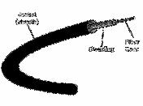
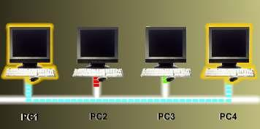
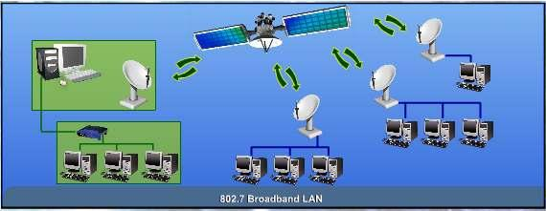

802.3 ETHERNET LAN
The 802.3 standard is the standard for an Ethernet
LAN. In 802.3, Ethernet refers to the physical
cabling, while the way data is transmitted through
the cable is called Carrier Sense Multiple Access/
Collision Detection (CSMA/ CD).

This method of transmission requires that only one
M. Amin, SMK Raja Shahriman

device on the network can be transmitted at a time. If another device can
sense that a transmission is already in the cable, it will have to wait. All the
other devices on the network will also sense and wait until the line is clear
before one of them can transmit data along the cable.

802.7 BROADBAND LAN
802.7 is the standard specifications for a Broadband LAN. This 802.7
standard provides specifications for the design, installation and testing
needed for broadband transmissions. Broadband transmissions allow
simultaneous multiple transmissions or signals using different
communications channels at the same time.

183




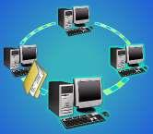
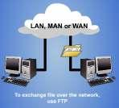
802.8 FIBRE-OPTIC LAN AND MAN
M. Amin, SMK Raja Shahriman

Specifications for a Fibre-Optic LAN and MAN are given
under the 802.8 standard. This standard gives the
recommendations for the configuration and testing of
fibre-optic Local Area Networks and Metropolitan Area
Networks.

802.11 WIRELESS LAN
This standard defines communication between a wireless computer or client
and an access point or between two wireless computers or clients.

The 802.11 standard uses the 2.4GHz frequency band to transmit data up to
2Mbps.

LESSON 84
PROTOCOLS

PROTOCOLS
Protocols provide the rules on how computers
communicate. They define how devices
intercommunicate in a network environment.

THE IMPORTANCE OF PROTOCOLS
Before protocols were developed, intercommunication
between devices was not possible. Protocols are
important as they define how devices, applications or
computers communicate in a network.

When two computers on a network perform a single
exchange of data or information, they will be busy
looking for the best communication process between
them.

184

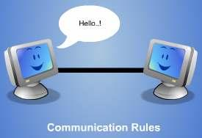
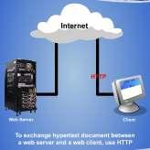
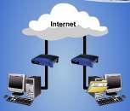
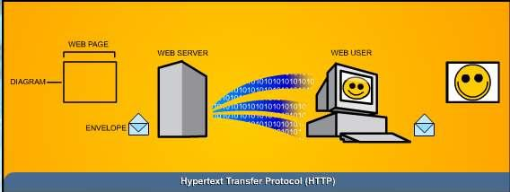
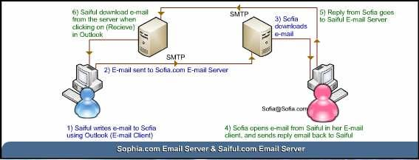
M. Amin, SMK Raja Shahriman

For example, there will be a protocol to specify
the format that the information bits or packets
must contain when traveling across this
connection.

There are also protocols that are responsible for
ensuring that the information bits or data
packets are sent or received in a proper
sequence.

All these protocols work
together as a group to
prepare and process
data for an exchange of
information over a
network. We call such a
group a protocol stack
or a protocol suite.

SOME TYPES OF PROTOCOLS

Hypertext Transfer Protocol (HTTP) – This protocol is used to access,
send and receive Hypertext Markup Language files (HTML) files on the
Internet.

Simple Mail Transfer Protocol (SMTP) – This protocol is used for
transferring e-mail between computers.
185
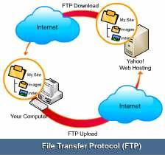
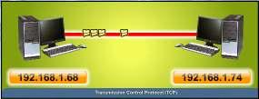
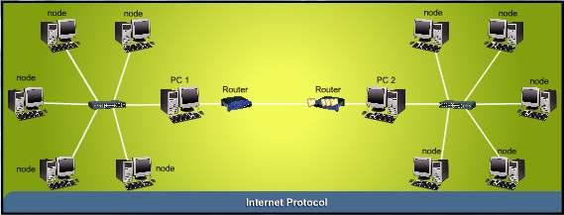
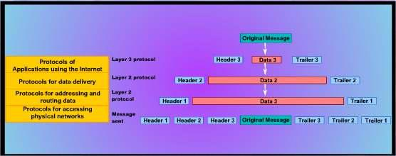
M. Amin, SMK Raja Shahriman

File Transfer Protocol (FTP) – FTP is
responsible for allowing files to be copied
between devices.

Transmission Control Protocol (TCP) – This protocol ensures the delivery
of information packets across network.

Internet Protocol (IP) – This important protocol is responsible for
providing logical addressing called IP address to route information between
networks.

LESSON 85
INTRODUCTION TO TCP/IP

For communications across the Internet, we need to have protocols to
demonstrate how data should be packaged and sent. TCP/IP is the
communication protocol suite on the internet. It has a number of protocols
controlling and handling data communication on the internet.

TCP/IP stands for Transmission Control Protocol / Internet Protocol.
186
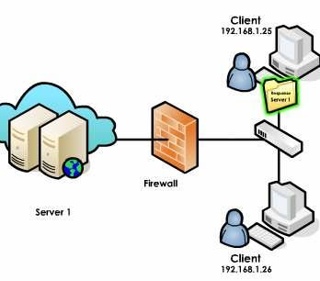
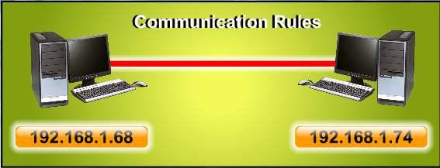
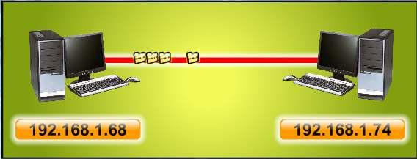
M. Amin, SMK Raja Shahriman

TRANSMISSION CONTROL PROTOCOL / INTERNET
PROTOCOL
TCP/IP (Transmission Control
Protocol / Internet Protocol) is the
internet communication protocol.

It is a standard that sets the rules
computers must follow in
communicating with each other on
a network. Some refer TCP/IP as
the Internet Protocol Suite.

When you use any applications or
programs to access the Internet,
these application will use TCP/IP to
achieve the task.

For example, when you want to
surf a network, you will use the internet browser. Your browser then uses
TCP/IP to request services from Internet servers. These servers will use
TCP/IP to send the web pages you requested back to your browser.

TRANSMISSION CONTROL PROTOCOL

TCP (Transmission Control Protocol) is the protocol that sets the
communication rules between computers. Here, TCP establishes connection
between two computers, protects against data loss and data corruption.

TCP is responsible for breaking the data into packets before they are sent.
TCP then assembles the packets when they reach a destination.
187

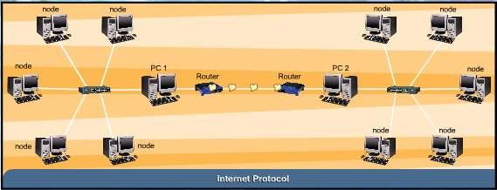
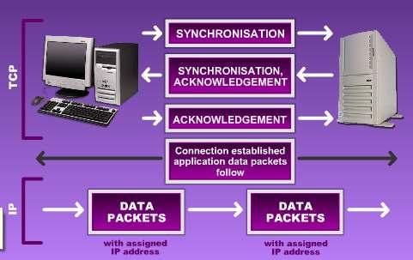
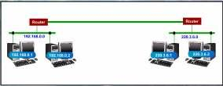
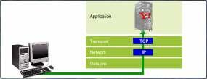
INTERNET PROTOCOL
M. Amin, SMK Raja Shahriman

IP (Internet Protocol) is the protocol that transfers data from node to node.
Here, IP takes care of delivering data packets between two computers. IP is
responsible for sending the packets from sender to receiver.

LESSON 86
THE WAY TCP AND IP WORK

Each computer must have an IP address
assigned by the network administrator to
access the internet. Let say yours is
192.168.0.1.

When you access a web page, for
example the Yahoo main page, the
TCP/IP will make the communication
work between your computer and the
Yahoo server.

188


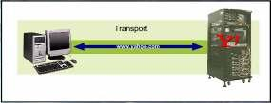
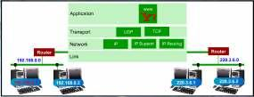
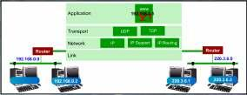
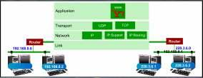

M. Amin, SMK Raja Shahriman

First, you type the URL address
“www.yahoo.com”on the browser. The
TCP will send a request for the web page
on Yahoo server according to the address
you typed in.

TCP will establish a connection between
two computers which is yours and Yahoo
server and it will prepare the full-duplex
communication.

A full-duplex system allows communication in both directions, and unlike half-duplex, allows
this to happen simultaneously. Land-line telephone networks are full-duplex since they
allow both callers to speak and be heard at the same time. A good analogy for a full-duplex
system would be a two lane road with one lane for each direction

The IP will begin sending the data
request from 192.168.0.1 to
‘www.yahoo.com’ or 209.131.36.158.

The Internet is a huge collection of
networks. There are many routes from
your computer to the server. IP will
send the data packets through these
routes as fast as possible. It will
constantly use several different routes
to deliver the packets to the
destination.

Meanwhile, TCP will continue to
maintain the link between the two
computers. TCP will close the
communication link once the web page
has reached your computer.

LESSON 87
PRIVATE COMPUTER NETWORK SETTING

Similar to mobile phones, computers connected to a network have:
A phone number (an IP address on a network).
Service provider identification, for example Maxis 012, Digi 016 and
Celcom 019 ( a subnet mask on a network).
Antennas ( a network gateway on a network).
A phone book function to help user put names to
telephone numbers ( a DNS server on a network).

189
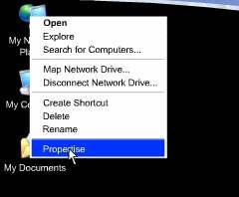
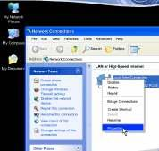
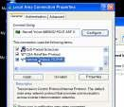
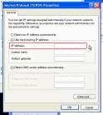
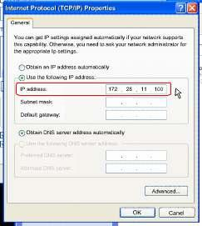
M. Amin, SMK Raja Shahriman
STEPS TO SETTING UP PRIVATE NETWORK
When you want to set up a private network for the school, you will need to
install the network card, IP address, Subnet mask and Default gateway.

1. Right click on the My Network Places icon on
the desktop and click the properties command.

2. In the Network Connections window, right click
on the network interface and click the
properties command.

3. In the network interface’s Properties dialog
box, click the Internet Protocol (TCP/IP) entry
and then click the Properties button.

4. In the Internet Protocol (TCP/IP) Properties
dialog box, select the Use the following IP
address option.

5. Type in the IP address in the IP address text
box, for example 172.28.11.100.

190
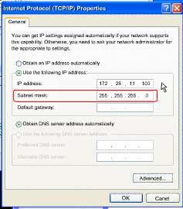
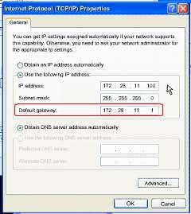
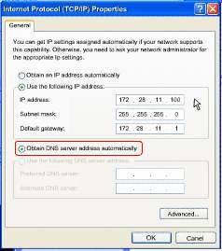
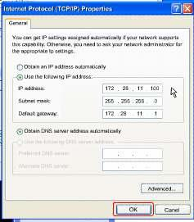
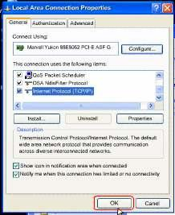

8. Make sure
address
M. Amin, SMK Raja Shahriman

6. Type in the Subnet mask in the subnet mask
text box with 255.255.255.0

7. Enter a default gateway with your server’s IP
address. Let’s say your server IP address is
171.28.11.1.

Obtain DNS server
automatically is chosen.

9. Click OK in the Internet Protocol (TCP/IP)
Properties dialog box.

10. Click OK in the external interface’s
Properties dialog box.

191




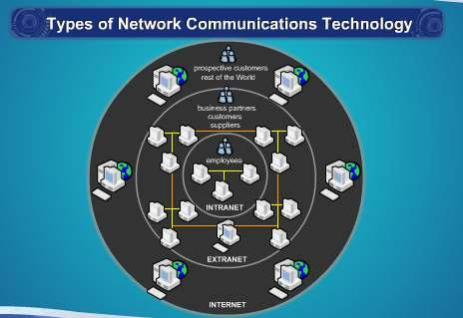
LESSON 88
M. Amin, SMK Raja Shahriman

TYPES OF NETWORK COMMUNICATION TECHNOLOGY

The Internet has become one of the
necessary things in our daily lives. A lot can
be done via the Internet.

We use the Internet to communicate with each other,
deal with money transaction, surfing for entertainment
and education.

For example, we can pay our utility bills using the
e-banking services as shown in the video.

The Internet is one of the types of network
communications technology besides intranet and
extranet.

192

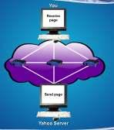

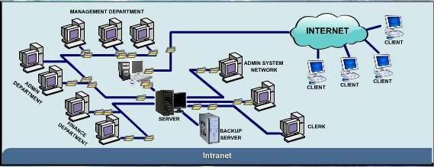

INTERNET
The Internet, or the Net, is the worldwide, publicly
accessible system of interconnected computer
networks that transmit data by packet switching
using the standard Internet Protocol (IP).

It consists of millions of smaller business,
academic, domestic and government networks,
which together carry various information and
services, such as electronic mail, online chat, and
the interlinked Web pages and other documents of
the World Wide Web.

Internet is one of the uses of
communication. Through the Internet,
society has access to global information
and instant communication.

INTRANET
M. Amin, SMK Raja Shahriman

An Intranet (intra means within) is an internal network that uses Internet
technologies and it is a small version of the Internet that exists within an
organisation.

An intranet is a private computer network that uses
Internet protocols, network connectivity and
possibly the public telecommunication system to
securely share part of an organisation’s information
or operation with its employees.

Intranet generally make company information accessible to employees and
facilitate working in groups.

Simple intranet applications include electronic publishing of organisational
materials such as telephone directories, event calendars and job postings.

193

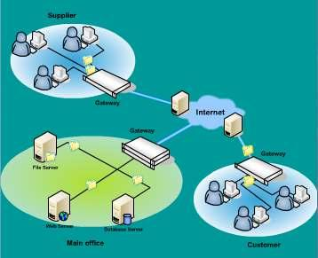


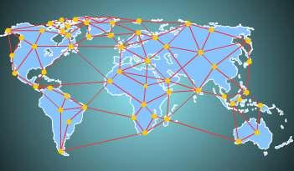

EXTRANET
An extranet is a private network that
uses Internet protocols, network
connectivity, and possibly the public
telecommunication system to securely
share part of a business’s information
or operations with suppliers, vendors,
partners, customers or other
businesses.

Package shipping companies, for
example, allow customers to access
their network to print air bills, schedule pickups,
and even track shipped packages as the packages
travel to their destinations.

LESSON 89
INTERNET
M. Amin, SMK Raja Shahriman

The Internet was created in the 1960s by people with great vision. They saw
the great potential value in allowing computers to
share information on research and development in
scientific and military fields.

Nowadays, when Internet is mentioned, it means
convenience, speed and economical. Many tasks can
be accomplished without having to travel far, spend
too much money or even wait for responses.

INTERNET

The Internet is the world’s
largest computer network
which connects millions of
computers all over the world.

Many organisations including
private as well as government
agencies, educational
institutions and individuals are
connected to the Internet.

194


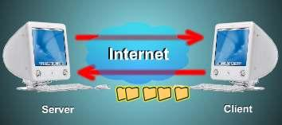




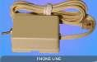




Some of the many usages of the Internet are:
Information; research & exchange
Commerce
real time communication
banking
shopping
entertainment
education
gaming
M. Amin, SMK Raja Shahriman

Internet transmits data by using Internet Protocol (IP).

INTERNET ACCESS
To access the Internet, users need to
subscribe services to an Internet Service
Provider (ISP). An ISP can either be a
telecommunication company or any
other organisation specialising in
providing access to Internet services.

Our Ministry of Energy, Water and Communications has licensed 6
telecommunication companies to provide telephony services in Malaysia.
Currently, only four of them are providing Internet services, they are Jaring
by MIMOS, TMnet by Telekom Malaysia Berhad, Maxisnet by Maxis
Communications Bhd and Time.net by Time dotcom Berhad.

Internet connection is divided into two categories; dial-up or broadband.

For dial-up connections, a phone line and modem are needed to access the
Internet while broadband connections use cable modem or router.

195

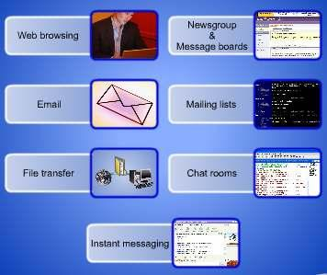
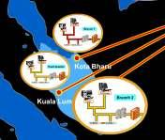
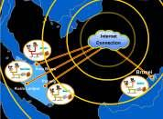
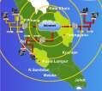

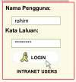
INTERNET SERVICES
Internet users can access services like:

Web browsing
Email
File transfer
Newsgroup&amp;Message boards
Mailing lists
Chat rooms
Instant messaging.

LESSON 90
INTRANET

INTRANET
With new technologies many of our tasks can
be performed with a click of a few buttons.

Company operations are now not just limited
within very tall buildings or between two
buildings located within the city. They are also
available between cities, states and even
countries.
M. Amin, SMK Raja Shahriman

The intranet technology allows sharing of valuable information and lets
business activities carry on even without a key personnel present at the
business premises.

USES OF INTRANET
An Intranet is an internal network that uses
Internet technologies. It is a small version of the
Internet that exists within an organisation.

Intranet generally make company information
accessible to employees and facilitate working in
groups.

To access intranet, employees need to be online. To let the
employees access the intranet fro everywhere around the
world, every employee will be given the intranet address,
user name and password.
196



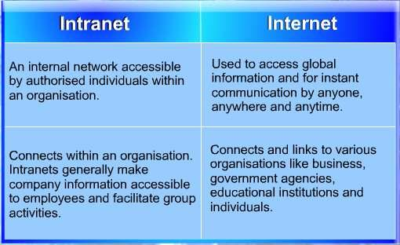
M. Amin, SMK Raja Shahriman

Intranet usually includes electronic publishing of materials related to an
organisation such as:

Telephone directories
Event calendars
Employee handbook
Job posting
Email services
News bulletin
Company forms
Staff information

Intranets too are used to conduct more
sophisticated tasks such as:
Groupware applications in project
management.
Remote discussion rooms (chat rooms)
Group scheduling
Video conferencing

COMPARISON BETWEEN INTRANET AND INTERNET

197

